Getting Started with CourseMate!
(For Students NOT USING ANGEL)

Benefits of Using CourseMate

CourseMate brings course concepts to life with interactive learning, study, and exam preparation tools that support the printed textbook. Learning tools include quizzes, flashcards, videos, and more. You can take notes, highlight, search and interact with embedded media specific to their book.

Where to Buy

Bookstore : CourseMate is available bundled with your textbook for a valuable savings at the bookstore.

First Time Login

To get started, navigate to: www.cengagebrain.com. If this is your first time using a Cengage Learning Product, you will need to create a new account.

Register as a New User
➔ Select “Sign Up” in the top right corner of your window.
➔ Fill in all fields that have a red asterisk (*) and click “Sign Up”.
➔ Once completed, you can then click on the “Homepage” link to be taken directly into your new CengageBrain account.

Returning Users

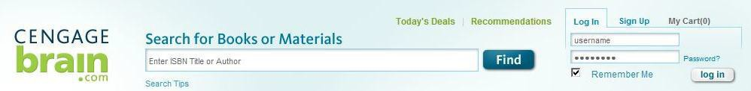
If you are a returning user, open your browser and go to http://cengagebrain.com and click on “Login”. Your username will be the email address you used to create your CengageBrain account.) If you forget you password at any time, use the Password link to retrieve your password.

Adding an Access Code and Course Key

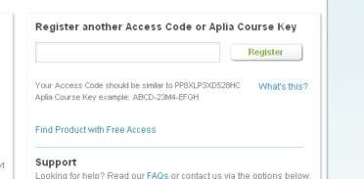
To add your Access Code, enter the Access Code into the Registration field. Make sure to enter the code exactly as you see it.

When your screen refreshes, you will see under “My Courses and Materials” you Cengage Course and an Open button. Click on the Open button next to your course title. The first time you take this step you will need to enter your Course Key.
➔ You will add a Course Key that will be given to you by your instructor so that you can join his or her class. You only need to enter your Course Key one time.

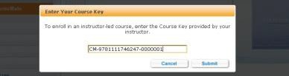

Questions?

Questions with your CengageBrain account? | Questions regarding CourseMate?
Check the FAQs in the Support area of your CengageBrain home. Write to cengagebrain.support@cengage.com  Call 866.994.2427 Mon. through Fri. from 8 AM to 6 PM EST | Go to www.cengage.com/support for 24/7 live chat!  Call 800.354.9706 Mon. through Thurs. 8:30 AM to 9 PM EST and Fri. 8:30 AM to 6 PM EST

